POE Part 2

**Rosebank College**

**Human Computer Interaction**

**HCIN6222**

**DUE: 22 October 2025**

Mentor Lukheli

ST10457167

Contents

**Overview**. 8

**Website Functionality** 8

**1. User Accounts and Profiles** 8

**2. Vendor Listings and Menus** 8

**3. Smart Search and Filters** 8

**4.** **Real-Time Order Tracking** 8

**5. Ordering and Checkout Process** 8

**6. Peer-to-Peer Delivery System** 9

**7. Group and Split Orders** 9

**8. Ratings, Reviews, and Social Features** 9

**9. Notifications and Feedback** 9

**10. Accessibility and Compatibility** 9

**Design Principles** 9

**Simplicity** 9

**Consistency** 9

**Feedback** 10

**User Control** 10

**Interaction Types** 10

**Direct Manipulation** 10

**Form Entry** 10

**Search and Filter** 11

**Usability Goals** 11

**Desirable Aspects of User Experience** 11

**Social Interactions** 12

**Emotional Interaction** 12

**WEB Content Accessibility Guidelines (WCAG) 2.0** 12

**Website Prototype** 13

13

14

**Conclusion** 14

**Overview**

University students often face significant time pressures due to various responsibilities. These include attending classes, completing assignments, and studying for exams. Such busy schedules leave little time for breaks, especially when trying to find quick and affordable food on campus. Traditional food delivery services usually do not meet students' specific needs. They often charge high fees and fail to integrate with campus meal plans. Additionally, they typically do not work with campus-specific or student-run eateries. To address these challenges, I propose Deli-Drop, a web-based and mobile-friendly food delivery platform designed specifically for university campuses. By connecting students with local campus food vendors and nearby restaurants, Deli-Drop aims to provide a fast, affordable, and student-friendly food delivery service. The platform will focus on ease of use, affordability, and community involvement, allowing students to access meals without losing valuable study or leisure time.

**Website Functionality**

The Deli-Drop platform will serve as both a web application and a mobile-friendly app designed for simplicity, accessibility, and speed. It will offer a complete food ordering and delivery experience tailored for university students. The website’s main features will include:

**1. User Accounts and Profiles**

Students can register and log in using their university email or single sign-on credentials. Each user will have a personalized profile with saved delivery addresses (like dorms or campus buildings), preferred payment methods, and dietary preferences. Returning users will access their order history and reorder with one click.

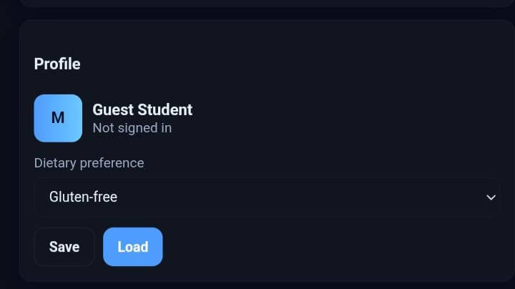

**2. Vendor Listings and Menus**

The homepage will feature a list of nearby campus vendors and student-run kitchens, each with their own profile page showing menus, operating hours, ratings, and delivery times. Vendors can update menus, add special offers, and manage availability in real time.

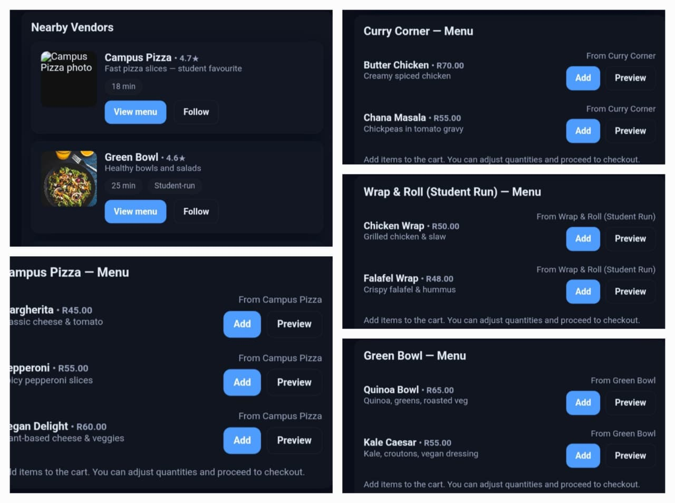

**3. Smart Search and Filters**

An intelligent search bar with autocomplete will allow users to quickly find food using keywords (like “pizza,” “vegan,” or “halal”). Filters will help narrow results based on cuisine, price range, delivery time, or dietary restrictions, ensuring users find meals that meet their needs.

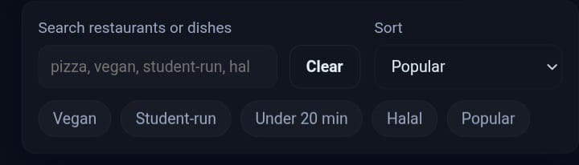

**4. Real-Time Order Tracking**

Once an order is placed, users can track it in real time. A live map and animated progress bar will display preparation and delivery status updates (“Order Received,” “In Progress,” “Out for Delivery,” etc.), providing transparency throughout the process.

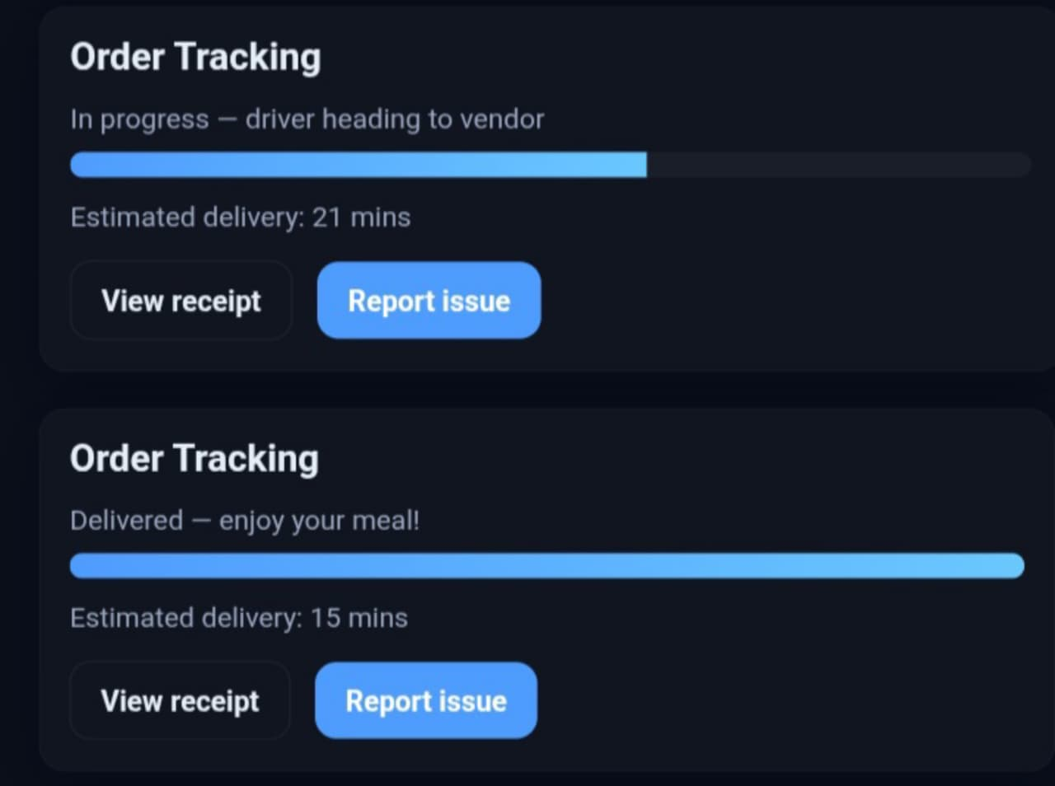

**5. Ordering and Checkout Process**

Users can easily add meals to their cart using intuitive drag-and-drop or tap gestures. The checkout process will be streamlined into a few clear steps: order summary, payment selection, and confirmation. Progress indicators will show how many steps remain. Users can modify orders before confirming and receive an instant confirmation message once payment is successful.

**6. Peer-to-Peer Delivery System**

Students can apply to be delivery drivers through their profile dashboard. Accepted drivers will receive delivery requests through a mobile-friendly interface, allowing them to accept or decline based on proximity and availability. This system promotes flexibility and student employment opportunities.

**7. Group and Split Orders**

The system will feature group ordering, allowing multiple students to order together. Each member can select their items, and the total can be split automatically. This feature is especially useful for study groups, clubs, or dorm gatherings.

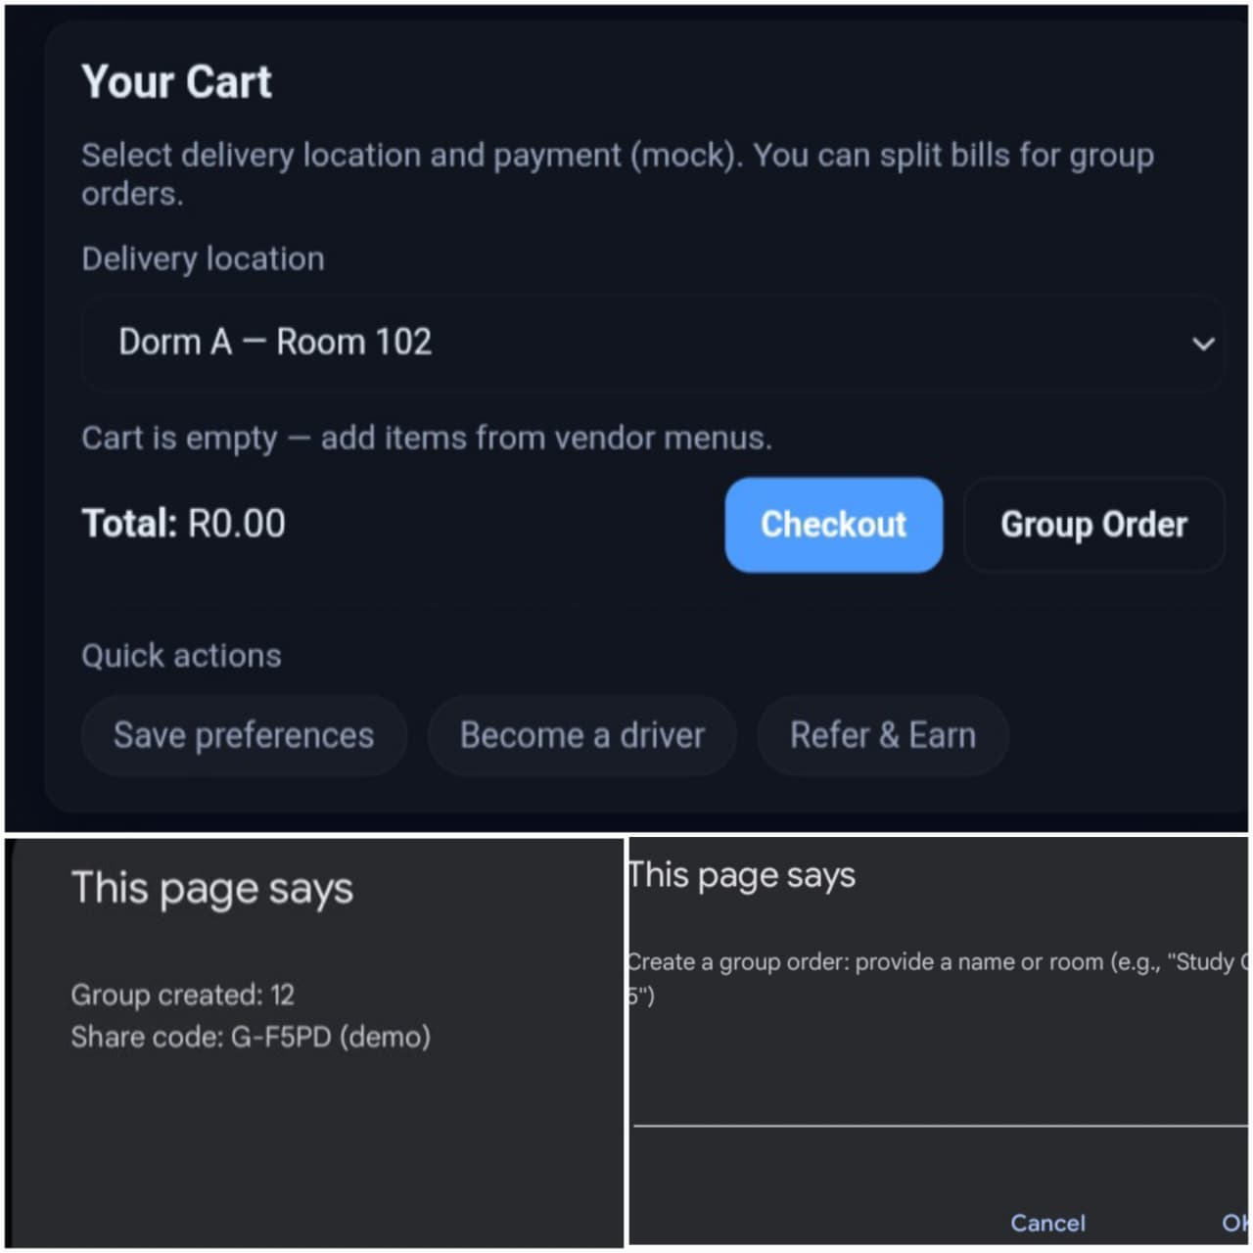

**8. Ratings, Reviews, and Social Features**

Users can leave star ratings and written reviews for vendors and delivery drivers. Social features like referral bonuses, loyalty badges, and leaderboards (like “Top Rated Driver of the Week”) will increase engagement and community trust.

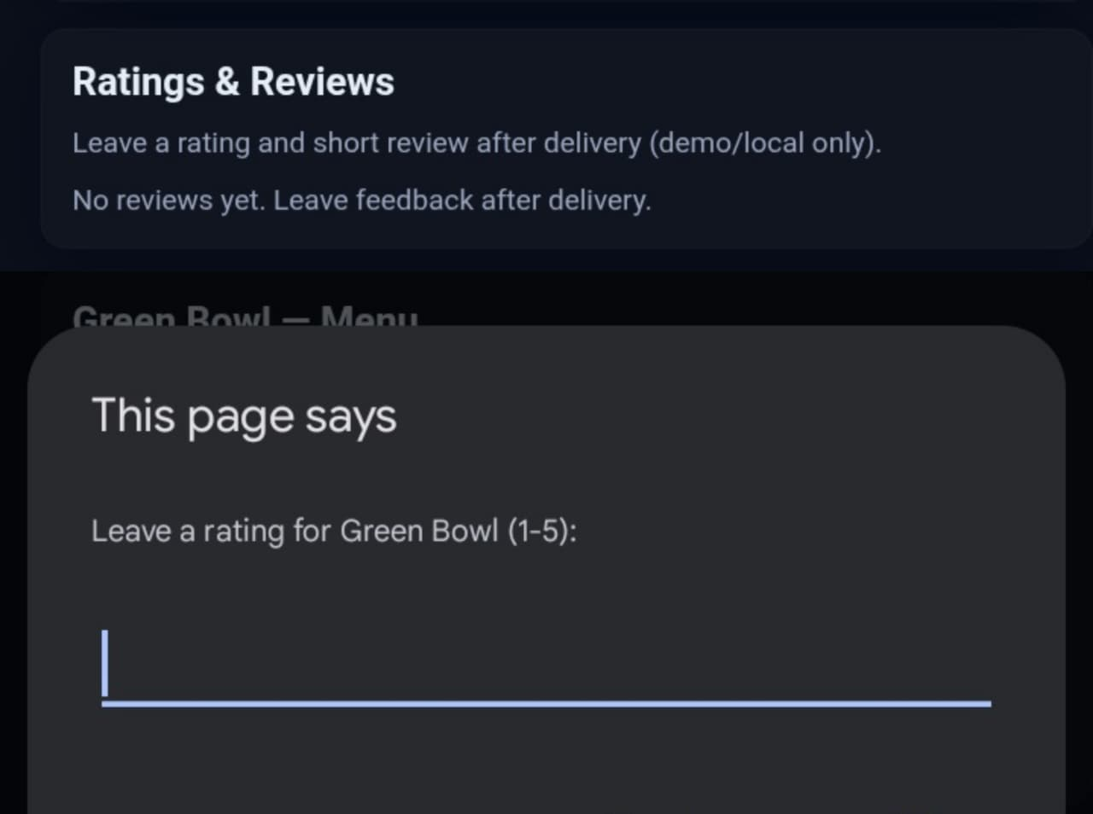

**9. Notifications and Feedback**

The platform will use visual and sound notifications to inform users about order milestones. After delivery, customers will be invited to fill out a brief feedback form to help improve service quality.

**10. Accessibility and Compatibility**

The Deli-Drop website will meet WCAG 2.0 Level AA accessibility standards. It will support screen readers, keyboard navigation, adjustable text sizes, and high-contrast viewing modes. The website will be fully responsive, ensuring seamless performance on desktops, tablets, and mobile devices.

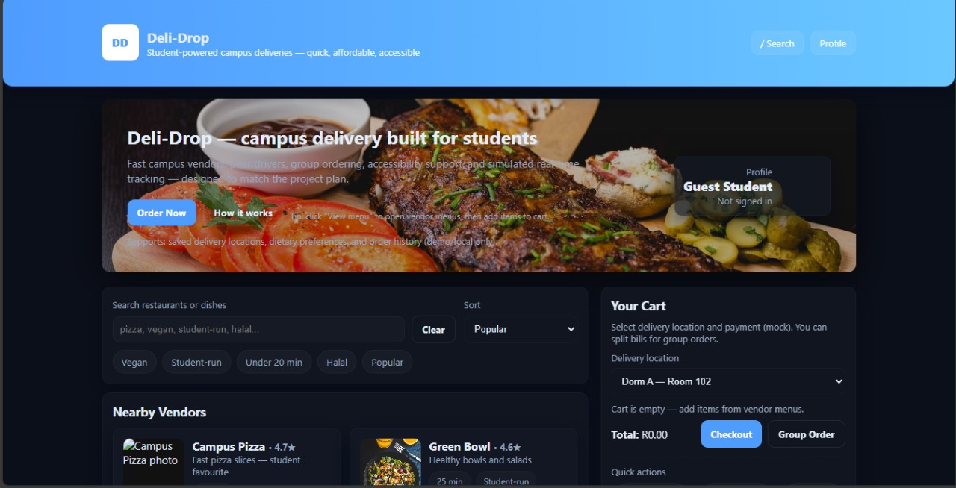

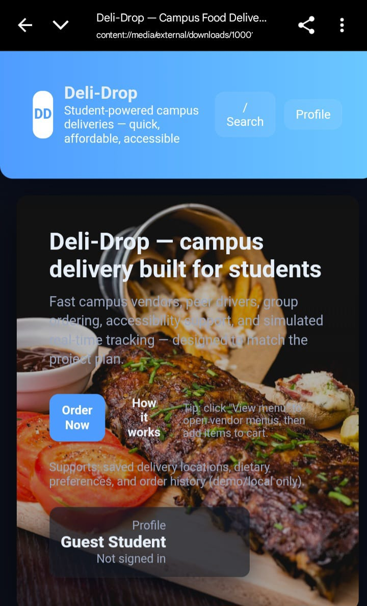

**Design Principles**

**Simplicity**

Simplicity is crucial to Deli-Drop’s design. I will create a minimalistic user interface that highlights only the essentials for ordering food. By reducing distractions, users can focus on completing their orders quickly. Prominent buttons like “Order Now” and “Track Delivery” will guide users through each step. The user journey will be linear, making it easy for first-time users to navigate confidently and without complications.

**Consistency**

Visual and functional consistency across all pages and devices is important for a smooth user experience. We will use a uniform color scheme, consistent fonts, and a set of icons that fit with university branding. Navigation elements like menus, shopping carts, and order summaries will consistently appear in fixed locations to help users feel familiar with the layout. This consistency develops muscle memory, reduces the learning curve, and helps users navigate the platform more efficiently over time.

**Feedback**

User feedback is key for transparency and trust during the ordering process. Deli-Drop will provide immediate, clear responses for every user action. After placing an order, users will see a confirmation message and a subtle animation to reassure them that their request is being processed. Any errors during form completion, such as missing delivery addresses or incorrect payment details, will be highlighted immediately with messages explaining what went wrong and how to fix it. Additionally, users will receive real-time delivery updates featuring animated progress bars and maps to continuously inform them about their order status, helping reduce anxiety and increase user satisfaction.

**User Control**

Giving users control over their orders and preferences increases their trust in the platform. Deli-Drop will allow users to cancel or change their orders within a specific time before finalizing. Users can also update their profile details, including dietary preferences, payment methods, and delivery instructions, to ensure their orders meet their needs. In group orders, individual participants can remove themselves or change their choices before payment, which reduces mistakes and increases flexibility.

**Interaction Types**

**Direct Manipulation**

To create an engaging user experience, Deli-Drop will use direct manipulation techniques suitable for both desktop and mobile users. This will involve swipe gestures for navigating menus and drag-and-drop options for managing items in the shopping cart. Users will receive animated visual feedback for their actions, reinforcing a sense of control and responsiveness, making the platform feel dynamic. These interactions will improve usability on mobile devices, where touch navigation is the main method.

**Form Entry**

Form entry will focus on making the checkout process as smooth as possible. Forms will be concise, with clear labels outside input fields for easy reading. Smart defaults, like automatically filling in dorm names after the first entry, will reduce repetitive typing. Dropdown menus and toggle switches will replace free-text input where suitable, simplifying data entry. A progress indicator will help users know how many steps are left in the checkout process. After delivery, users will be invited to fill out a brief, optional feedback form to rate their experience, designed to take only a few seconds.

**Search and Filter**

Recognizing that students often place orders between classes or during short breaks, Deli-Drop will implement effective search and filtering tools to speed up meal discovery. The search bar will provide keyword auto-suggestions, allowing users to type terms like “vegan” or “gluten-free” and quickly see relevant options. Filters for cuisine type, vendor ratings, delivery times, and student-run kitchens will help users narrow their choices effectively. This feature ensures students can quickly find meals that suit their tastes and tight schedules.

**Usability Goals**

Efficiency - The platform will enable students to place a food order in under three minutes, saving valuable time during busy academic days.

Learnability - The design will allow users to quickly understand how to navigate and use the platform confidently during their first session without requiring prior training.

Accessibility - Following accessibility standards will ensure the platform is usable by all students, including those with disabilities. Features will include screen reader compatibility, keyboard navigation support, and color contrast modes.

Responsiveness - The interface will function smoothly across all devices, whether desktop, tablet, or smartphone, offering an optimal experience regardless of screen size.

Feedback - Users will receive immediate visual and auditory confirmation after actions like order submission, along with live delivery tracking.

Error Recovery - Clear and concise error messages will help users resolve mistakes quickly. Undo options will be available where possible to minimize frustration.

Personalization - User preferences, saved orders, and dietary restrictions will be stored to customize future interactions and speed up repeat orders.

**Desirable Aspects of User Experience**

Comfortable - A familiar and clean interface using university branding colors and fonts will make students feel at ease and reduce their anxiety about using a new platform.

Trustworthy - Features like real-time delivery tracking and peer ratings for vendors and drivers will help build user confidence and encourage ongoing use of the service.

Convenient - Fast ordering processes, saved preferences, and the option to pre-schedule orders will reduce distractions and streamline meal planning.

Community-Oriented - By including peer-to-peer delivery options and supporting student-run kitchens, the platform will foster a sense of belonging and shared purpose among campus members.

Satisfying - Smooth interactions, combined with personalization and clear feedback, will ensure overall user experiences are enjoyable and rewarding.

**Social Interactions**

To enhance the community aspect of Deli-Drop, social features will be integrated directly into the platform:

Peer Delivery Drivers - Students can sign up as delivery drivers, creating flexible job opportunities that fit around their academic schedules.

Ratings & Reviews - Customers will have the opportunity to rate and review vendors and student drivers, providing social proof and accountability to maintain high service standards.

Referral Rewards - Incentive programs will encourage users to invite friends, helping to grow the platform’s user base through trusted peer networks.

Group Orders - The platform will support shared ordering with split payments, allowing student groups or clubs to easily order together and save on delivery fees, enhancing group engagement.

**Emotional Interaction**

Connecting on an emotional level is important for long-term user engagement:

Belonging - Featuring student testimonials and phrases like “student-powered delivery” will strengthen the feeling of community and shared purpose behind the platform.

Trust & Comfort - Utilizing familiar campus branding along with reliable delivery tracking will help build confidence and reduce anxiety related to food delivery.

Motivation - Adding gamification elements like loyalty points, achievement badges (like “Top 10 Campus Driver”), and progress tracking will encourage continued use and a sense of accomplishment.

**WEB Content Accessibility Guidelines (WCAG) 2.0**

To ensure inclusivity, Deli-Drop will follow WCAG 2.0 Level AA standards, which will include:

- Providing alt text for all images to assist screen reader users

- Supporting screen readers and voiceover tools for navigation and content access

- Offering high contrast themes and a dark mode option for users with visual impairments or preferences

- Allowing for full keyboard navigation and optimized tab orders to help users who cannot use a mouse.

- Using dyslexia-friendly fonts and allowing adjustable text sizes to support different reading needs.

**Conclusion**

Deli-Drop is designed to connect students’ busy academic lives with accessible, affordable, and convenient food options. By focusing the platform on the unique campus environment, promoting peer engagement, and emphasizing accessibility and usability, Deli-Drop addresses real student problems. The platform’s thoughtful design and scalable framework make it possible to expand from a single campus initiative into a national network of student-focused delivery services.

Deli-Drop does more than just provide food delivery. It supports student employment, peer interaction, and community building, helping students feel empowered and connected. Ultimately, Deli-Drop aims to enhance campus life and improve students’ daily experiences, one delivery at a time.